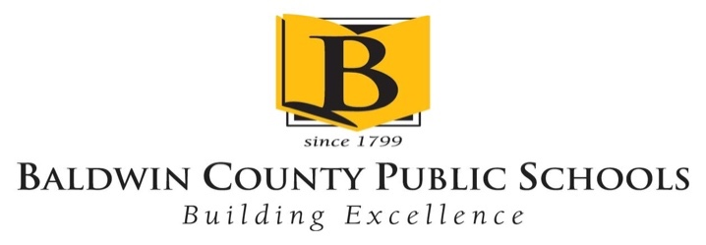

Baldwin County Public Schools
Instructional Support
Special Services Department

Student: ______________________________ Date: ____________________

Dear Parent/Legal Guardian:

As you may be aware, your child may be experiencing difficulties in school. Research indicates the sooner we provide intervention for these difficulties, the greater the likelihood of a successful school year.

We would like to do a vision and hearing screening to rule out any possibilities that vision and hearing may be adversely affecting your child’s performance in school.

We are requesting your consent to conduct this vision/hearing screening. Should you have questions, concerns, or wish to schedule a conference regarding this, please contact the school.

______________________________________________________________________

Please check, sign, and date below.

- I agree to the proposed vision/hearing screening.

- I do not agree to the proposed vision/hearing screening.

________________________________ _______________________
Parent/Guardian Signature Date

